Hungry Children (Drawing)
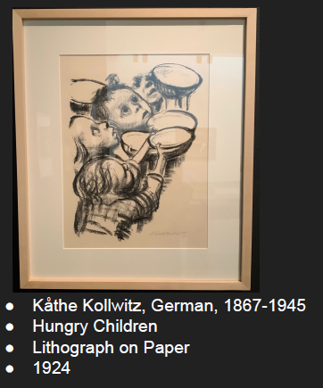
The art represents children holding their bowls in dire need of food. Tellingly, the drawing depicts that they are victims of food shortage. The children in the drawing look malnourished and destitute. Kathe Kollwitz, the author of the artwork aimed at highlighting the need to alleviate hunger by ensuring that sufficient food was provided to impoverished communities. She employed the use of various elements of design – space, shape as well as dominance and emphasis. In the drawing, she used negative space by leaving some parts blank to achieve the general image. The shape of the art was rectangular to denote the portion of the page covered. Dominance and emphasis of the drawing was to showcase hunger pangs children are exposed to and coming up with ways to resolve it. I like the art as it aims at creating awareness concerning food shortage. The children in the drawing are hungry and have their bowls pointed towards an unseen person asking for food. It relates to the contemporary world as there are increased instances of food shortage due to droughts. Hence the drawing champions the installation of programmes that are inclined to alleviating the issue of food shortage within the community.
Figure of a woman (sculpture)
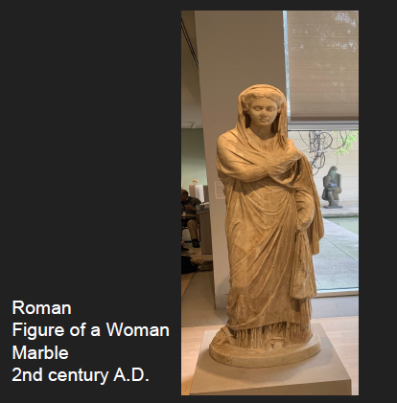
The composite statue portrays an honorable Roman matron who hails from a renowned family. She is remembered for being a chaste wife as well as a mother of children. The sculpture is used as an enduring value for celebrating marriage by depicting it as a symbol of Roman life. Its author used diverse elements of design such as shape, texture and color. The sculpture had depicted the shape of a draped figure of a Roman woman. It had a smooth texture by having a realistic face of a woman and had a brown color depicting its mood. I like the sculpture as it perfectly portrayed the culture and traditions of Romans. It is an art in the imperial society that embodies the high value given to respected Roman women. Furthermore, the sculpture emphasizes the values of a proper woman depicted in the cultures and traditions of Romans. It elucidates the respect accorded to distinguished women who hail from Rome. The figure is draped in attire that is worn during special ceremonies like funerals, civic or religious dedications. Therefore, I consider the sculpture to be a great of art that appreciates well-known Roman women in society.
Without Our Heads, We Prevail
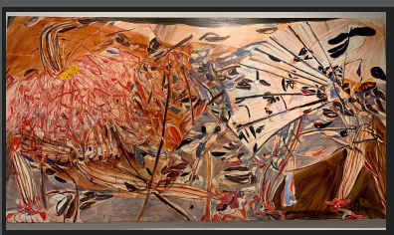
The painting denotes the significance of passion when pursuing art. The author developed the painting with the motive of evoking people’s thoughts through a graphic description. Her painting communicated the reverence of using abstract gestures along with familiar motifs. The painting aims at highlighting the need for being artistic when relating to various events within the geographic space people live. In the painting, the author used different elements of design. They included color, scale and space. The painting used a large scale by providing the pictorial view of the environment of characters. It is broad and gives an excerpt of the large environment. It uses a large space to portray the different figures within the environment. The painting has multiple colors such as black and brown to make more visually appealing. I like the painting in that it involves critical thinking when interpreting work environments. Also, it helps me understand the need to conceptualize the diverse features of artistry that exude creativity and innovation. However, I have some dislikes about the painting. Foremost, it is difficult to understand what the author intends to relay as the features on it are difficult to effectively interpret.
Ceremonial Cloth (Tampan) (Craft)
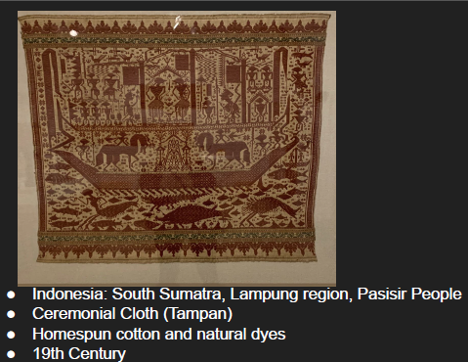
The artwork denotes a remarkable textile that was traded during periods of maritime trade in Indonesia. It was woven and had intricate features that portrayed the culture of the people hailing from the Lampung region. Some of them included decipherable symbols and human figures along with motifs. The ceremonial textile was used to cover ceremonial food at weddings.
The artist of the craft used varied elements of design to develop it – scale, color and space. There were precisely spaced repetitive patterns between the outer frame and indigo blue inner bands. The indigo blue inner bands made the craft have a good visual impression. The artwork used a large scale to cover numerous features like human beings, horses and fishes. Also, the artist used negative space by leaving some spaces blank with the aim of attaining the general image. I like the artwork as it unravels to me the cultural background of the Lampung region based on their traditions.

